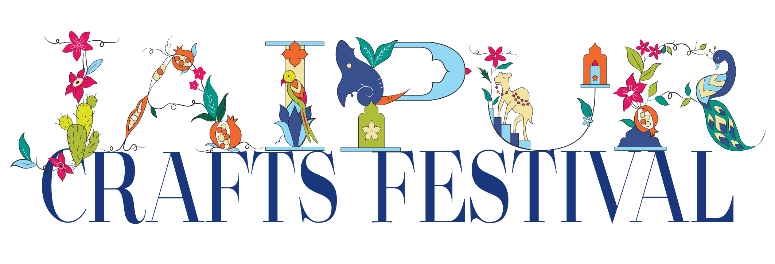

Dear Google, Facebook, Amazon, Microsoft; Schema Working Group and World Trade Organization (WTO),
We write to you as concerned makers, artisan organizations and e-tailers of handmade, sustainable, fair-trade goods. Three fields developed by Google, Facebook, Amazon, Microsoft and the Schema.org working group create the circumstances where Web search is biased against handmades. Only you, as barrier builders, can act to unlock e-commerce sales for crafts/handmades.
The three structured fields are 1) Google Taxonomies, 2) Schemas for handmades and 3) Harmonized Standard (HS) Codes. These fields bring structure, certainty, coherence and better customer experiences to search. Yet, important environment, sustainability and governance (ESG) dimensions are not included in these fields. Why is that? Omitting our beautiful, circular, culturally rich products means our work (and livelihoods) are buried underneath commercial goods in Internet search. Crafts/handmades differ from industrial products in almost every way. Customers who want our products are not usually interested in commercial goods. Put simply, exclusion from the three structured fields mean handmades/crafts can't be found, which hurts other social goods like climate goals and social justice activations.
Technology’s Role in the Craft Sector
In 1599, when the Mughal Empire produced over 37% of the world's GDP, India’s making secrets were the world’s most valuable technologies. Now, code is the world's most valuable technology and increasingly central to the craft sector’s success. We regard exclusion from the three fields as oversight, but hope you'll recognize that every day you don't act hurts around 200 million Indian livelihoods—and many more globally.
If you act now, the sale of handmades could jump by spring of 2023. If you don't act, suppression of the world's most beautiful cultural goods will continue until you do. One example of the misalignment: there is a Google taxonomy for hand warmers, but nothing for handmades. We’re saying that without search which acknowledges handmades, ready customers who cannot find what they want in search, give up and buy commercial substitutes.
Here is more about the three fields and why they matter to e-commerce sales:
Google Taxonomy
Today, products need a Google Taxonomy to qualify for, or rank well for sales on Google, Amazon, Facebook, Instagram and search in general. Example: The taxonomy for a handspun, handwoven, tailor-made, embroidered women’s jacket is:
• Apparel & Accessories > Clothing > Outerwear > Coats & Jackets."
The fairer taxonomy should be:
• "Apparel & Accessories > Clothing > Outerwear > Handmade Coats & Jackets."
Or,
• "Apparel & Accessories > Clothing > Outerwear > Mixed Handmade Coats & Jackets."
Schemas
Search Quality Scores and Search Engine Optimization are how goods and services get found online. It was easy to rise in the old Internet. The new Internet relies on many, many more factors. Structured Data, developed by the Schema Working Group, is the future of search. It tells the Internet exactly what the product is via dropdowns, tic-boxes and structured fields. This is why your omissions matter. Structured Data tells search exactly what a business does, who its customers are and to whom their products and services have meaning. Higher Quality Scores = Higher Search Traffic = More Sales.
Currently, there are no Structured Data schemas for handmades/crafts and their Environment, Social and Governance (ESG) dimensions. There are schemas for handwritten manuscripts and clothing stores, but not handmade clothing. The oversight means crafts will remain buried in search. Indefinitely.
HS Codes
The World Trade Organization (WTO) governs Harmonized System (HS) Codes that measure trade output and manage trade policy. In the absence of other tools, the Internet began using HS codes as a quality metric in search, which had the unintended consequence of punishing handmades. To extend our example, a tailored, benchmade women’s jacket made from handspun, hand-loomed cloth has the same HS code, 610432, as an industrial big fashion jacket.
This means handmades/crafts are not measured and commercial products get advantages crafts can never overcome.
To restate: 1) Customers globally can’t find heritage products via e-commerce search now, or in the future. 2) Craft sales can’t be measured in trade.
Crafts are key to sustainable fashion, a propellent for UN Sustainable Development Goals, vital to the success of Handmade in India and a tide that could lift all boats. The effects of your inaction are devastating because someone else in some other place will always win.
The bottom line is that the omission of crafts/handmades from the three structured fields is anti-competitive and unfair; inaction prevents friends and fans of craft from finding and buying our marvelous patrimony. Won't you help us?

